Exercise

- Steps(with command and screenshots) for installing apache
Answer: To Install apache write sudo apt-get install apache2 in terminal.
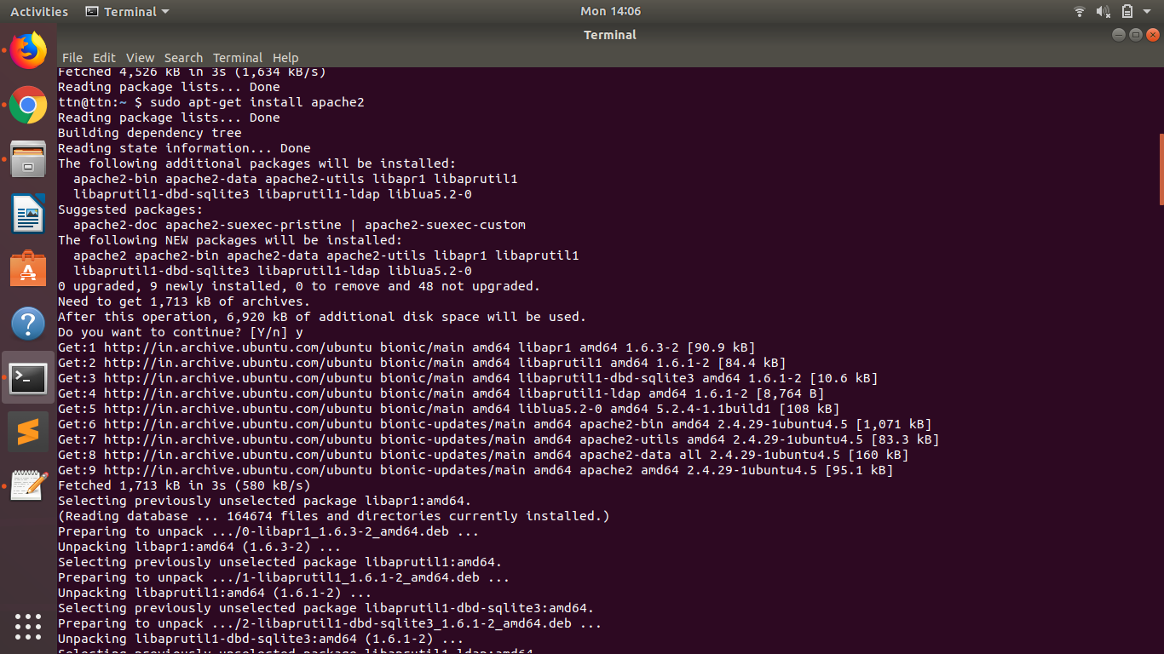

- Installation steps(with command and screenshots) Php and print current version
Answer: For installing php : sudo apt-get install php
For checking version : php --version
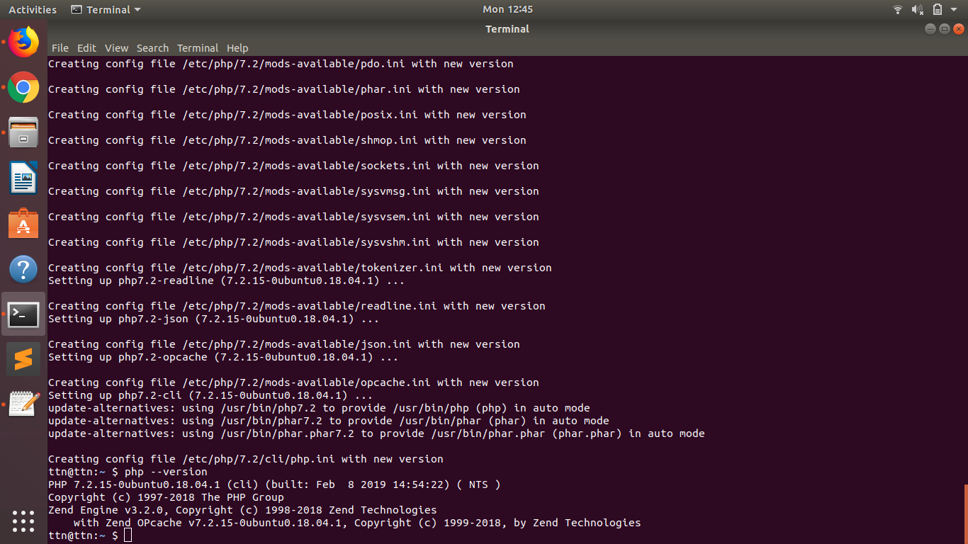

- Installation steps(with command and screenshots) mysql and print current version
Answer: Write sudo apt-get install mysql-server in terminal to install.
To check version write mysql --version in terminal.
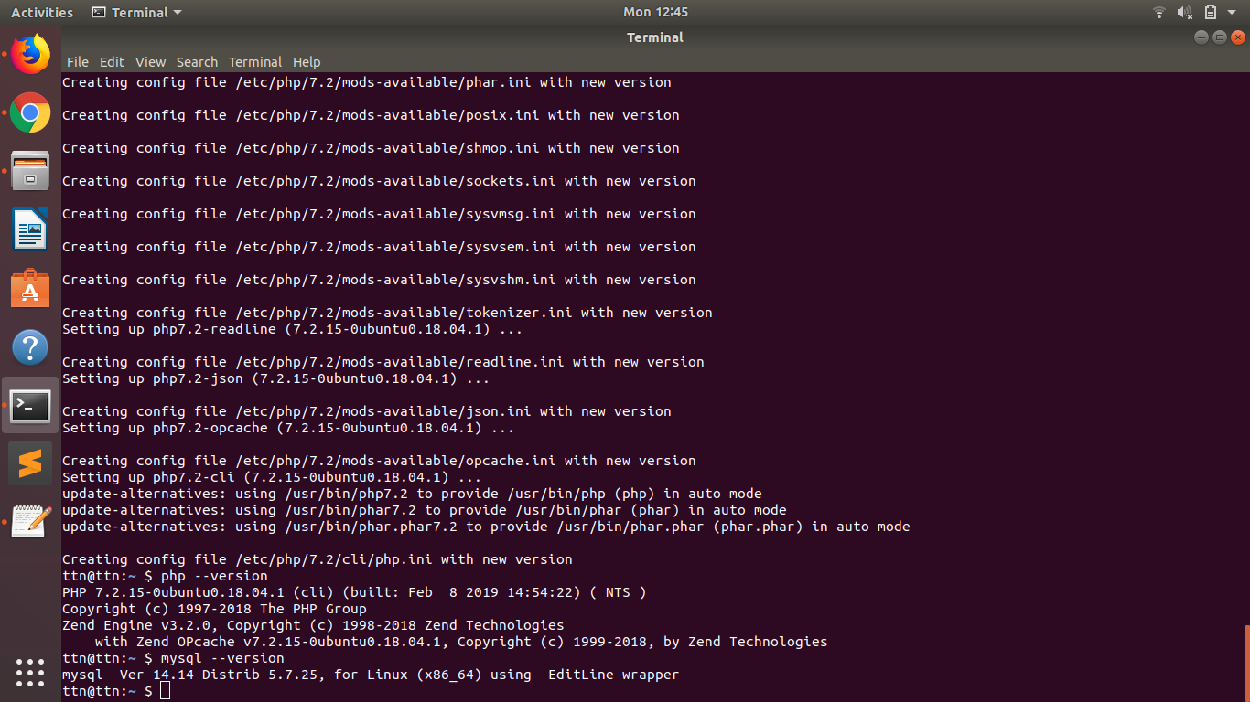

- What is HTTP?
Answer: HTTP (Hypertext Transfer Protocol) is the set of rules for transferring files (text, graphic images, sound, video, and other multimedia files) on the World Wide Web. As soon as a Web user opens their Web browser, the user is indirectly making use of HTTP. HTTP is an application protocol that runs on top of the TCP/IP suite of protocols (the foundation protocols for the Internet).

- What is the name of a superuser in Linux
Answer: Super User in Linux is : root.

- What domain name will have the following address – 127.0.0.1
Answer: localhost

- What language should you use for writing a queries for database?
Answer: sql (Structured Query Language).

- Which command is used for restart apache
Answer: $ sudo systemctl restart apache2
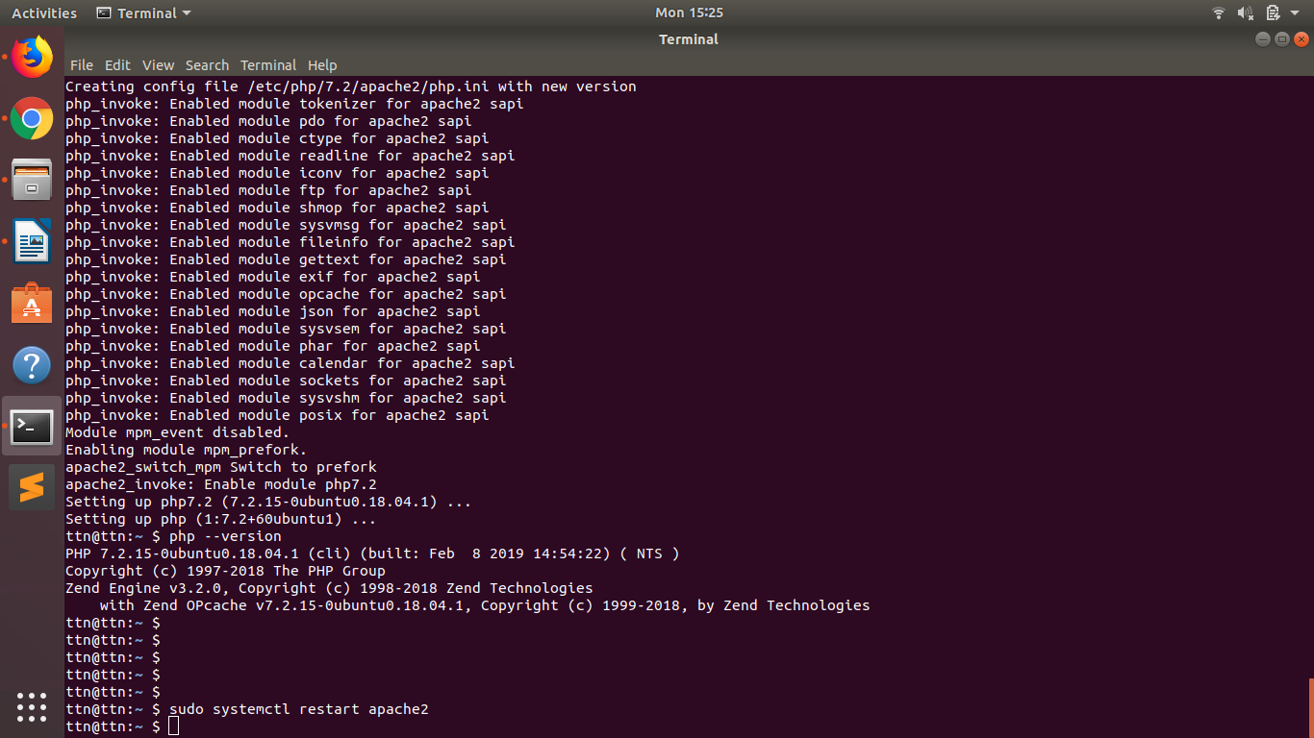

- Print fibonacci series
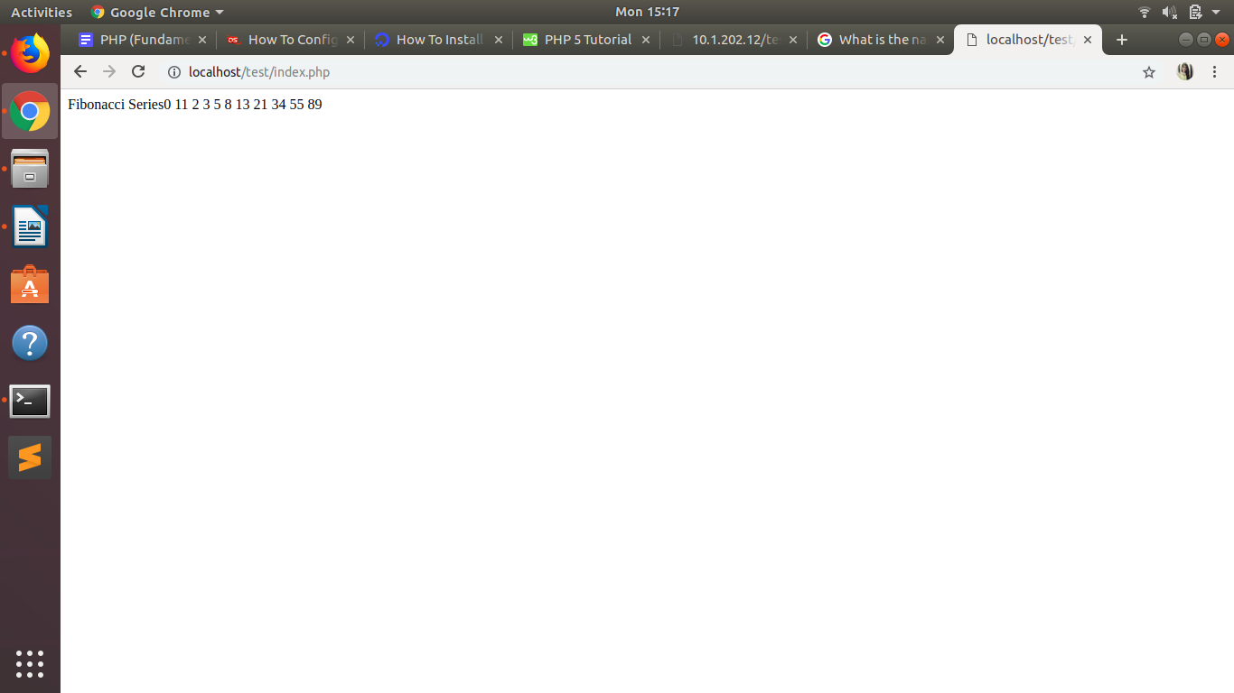
Answer: Localhost :

Remote Host:
